Process Silver Data(Configure DLT pipeline settings)

- 1) Navigate to the left-hand sidebar menu and click on Jobs & Pipelines. Then, create a new job by clicking on either Job or the Create button in the top-right interface.

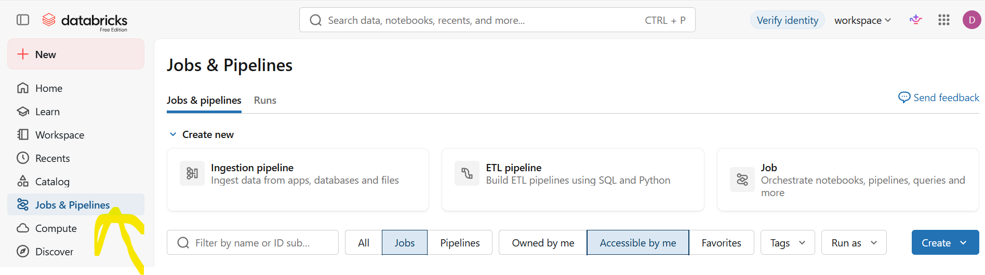

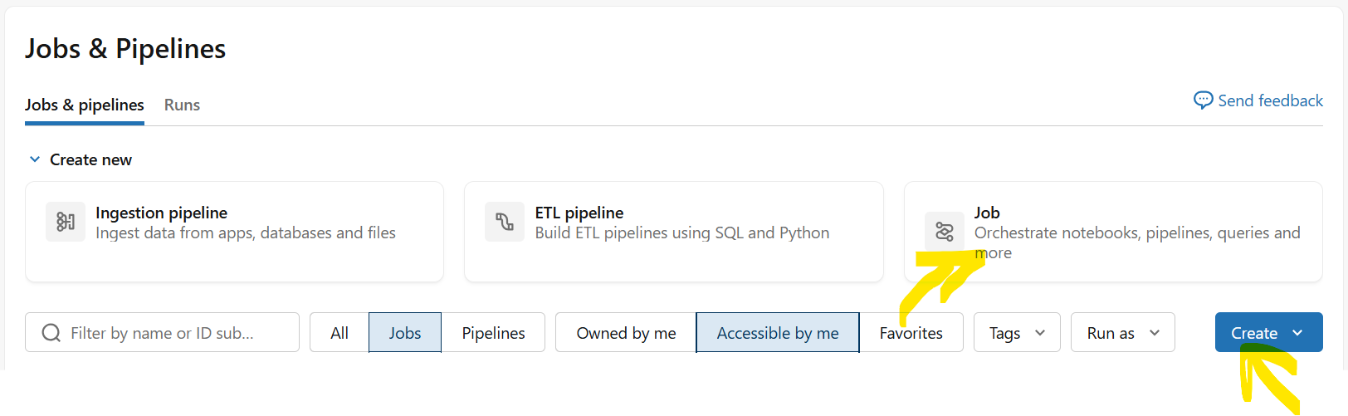

- 2) In the job configuration canvas, enter a descriptive title for your pipeline (e.g., silver-dlt-pipeline). Under the task selection choices, click on Notebook (Run a notebook) to define the type of task for this pipeline step.

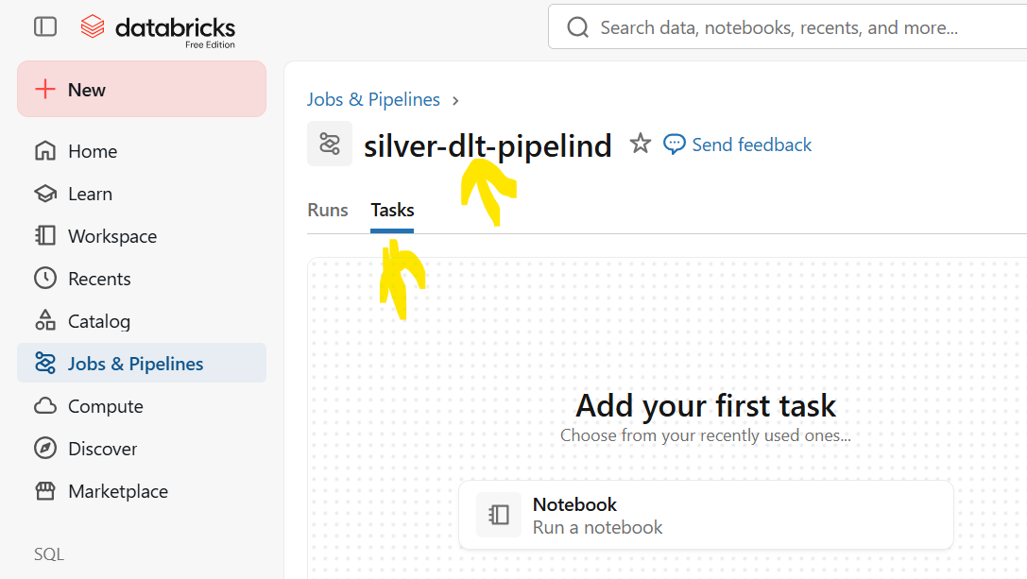

- 3) Locate the task settings panel on the right side. Scroll down to the Path field and click inside the input box (labeled Select Notebook) to open the file browser modal.
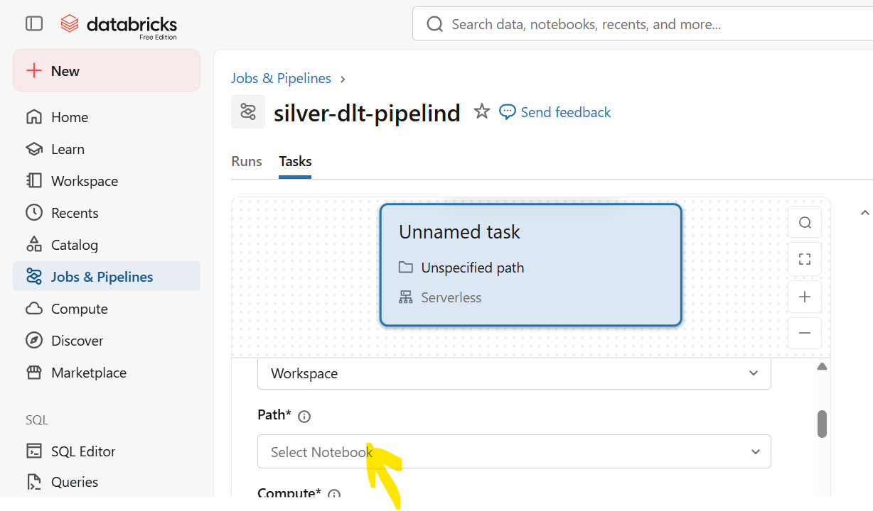

- 4) In the modal window, navigate through your workspace directory structure to find and select the intended notebook file, then click Confirm to link it to the task.

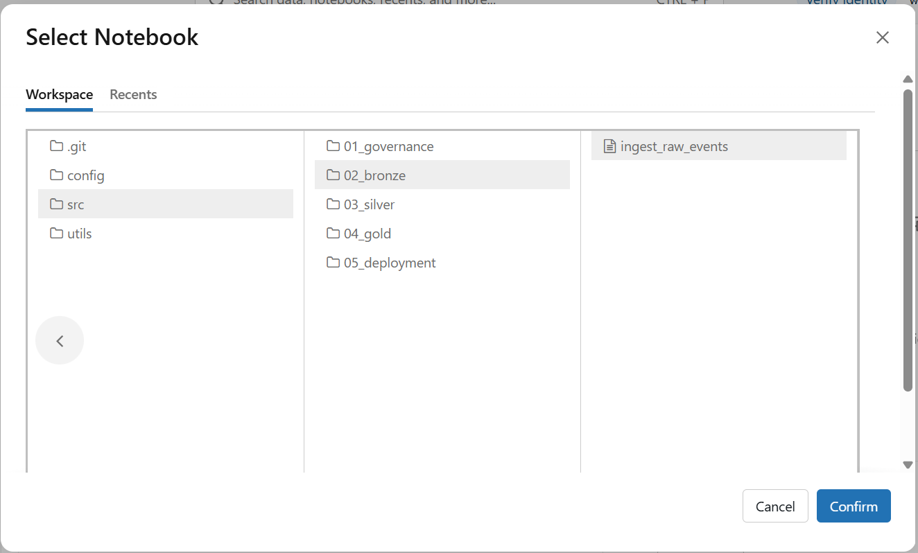

- 5) Verify the selected path details in the task configuration form, and then click Create task in the bottom-right corner to finalize adding the task.
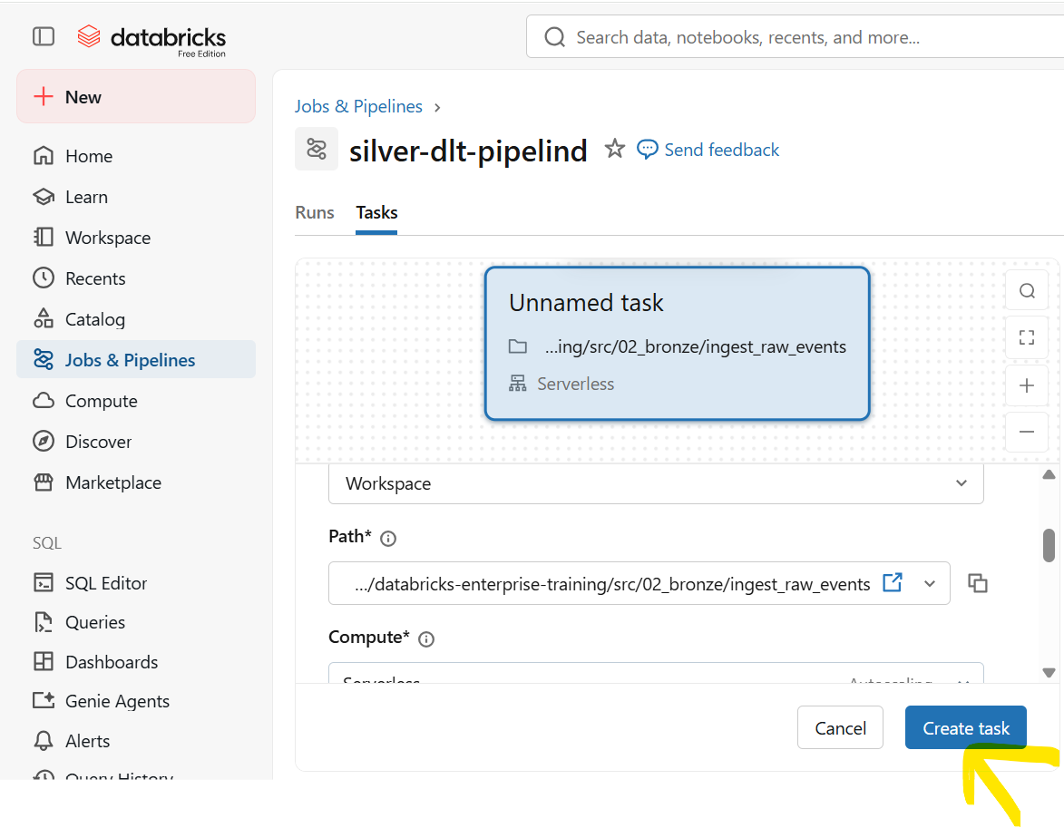

- 6) Assign a clear, unique identifier in the Task name field (e.g., dlt-automated-pipeline), and click Save task to apply your configuration.
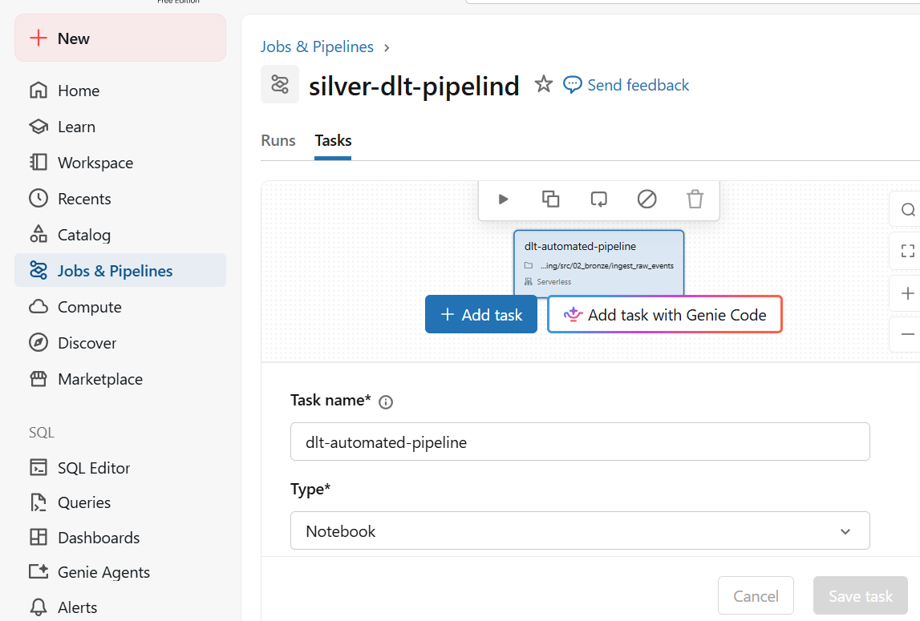

- 7) Once the task is configured and saved, review the job overview dashboard and click Run now in the top-right corner to initiate execution immediately.
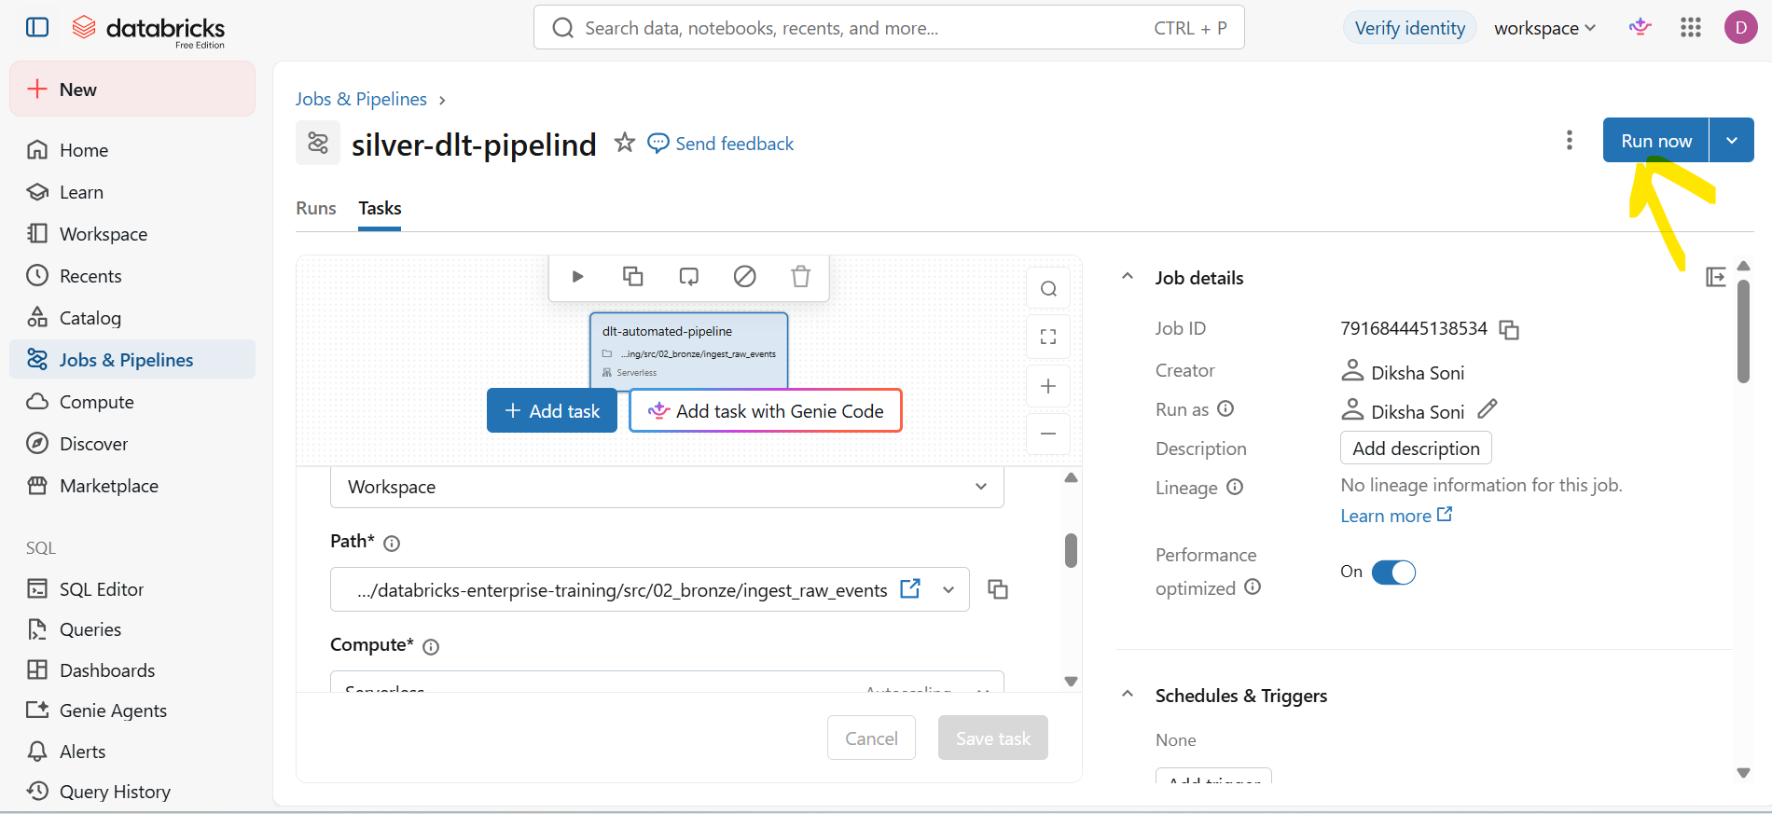

- 8) Monitor the run status in the execution graph and details panel to confirm that the pipeline workflow completes successfully.
